Table of Contents
Part I – Creating a new project in Visual Studio 2010 (or 2012, 2013, or 2015). 2
Step 1 - Open visual studio and from the top menu select File->New->Project 2
Step 2 - once the new project dialog opens do the following 2
Step 3 - Now we are going to add some files from the release folder. 4
Step 4 – From the top menu select Project->MefClientConsoleProperties or just right click the project in solution explorer and select properties. 5
Step 5 – Make sure that the “Application” tab is selected and from the Manifest drop down box select the “Create application without a manifest” option. Change Framework to .NET 4. Press the save button & save the project. 6
Step 6 – In the release folder locate the “mefclientsdk.config” file and drag it into your solution. Rename it to “app.config”. 6
Step 7 – Delete the “program.cs” file in the project and copy the over “program.cs” and “util.cs” from the SampleApp folder into the project. 7
Step 8 – At this point build the solution and you should see something like the following depending on your visual studio setup. 8
Part II – Working with the configuration values from the provided mefclientsdk.config. 9
Certificate Settings – The StoreLocation and StoreName properties 10
Certificate Settings – The X509FindType and FindValue properties 10
Certificate Settings – Identity dns value 11
Certificate Settings – Quick glance at config sections other than certificate 12
Part III – Walking through the samples in the console application. 13
Intro – This guides layout and examples. 13
Creating a ServiceContext 13
LoginClient 15
EtinStatusClient 16
GetNewAckNotificationsClient 17
Below is a shot of the list opened in notepad 18
The code view is on the next page. The view includes an example of one of the efileattachments api’s (shown below) which is not included in the console app. 19
Part IV – Troubleshooting. 21
MeFWCFClient.dll references - Everything compiled, my application runs, but… 21

Part I – Creating a new project in Visual Studio 2010 (or 2012, 2013, or 2015).
To run the walkthrough successfully you should already have your certificate installed, have gone through the steps in the installation guide, and saved the contents of the MefClientSdk release files somewhere on your hard drive.

Step 1 - Open visual studio and from the top menu select File->New->Project
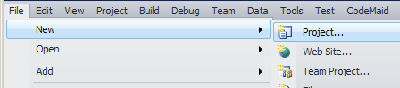

Step 2 - once the new project dialog opens do the following
- Choose a Console Application from the project item list
- Choose a name such as "MefClientSdkConsole" for your application 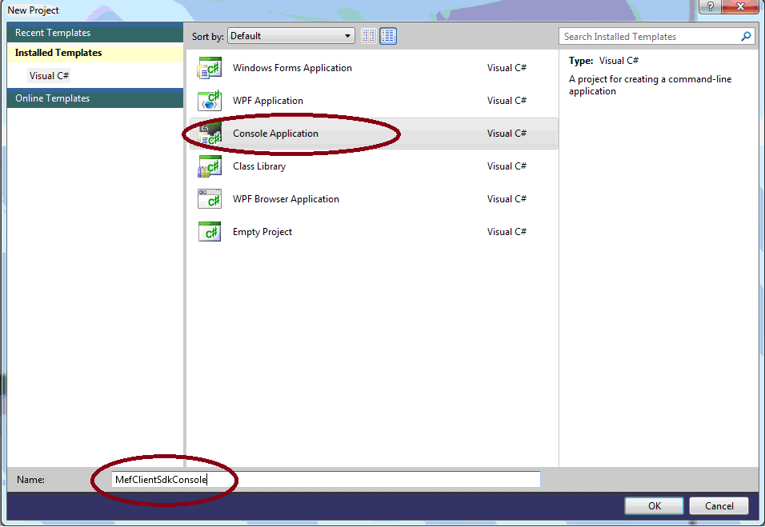
- Press the “OK” button to create the project.
- Once the solution opens, Click on Solution and then click save icon. Choose a directory and click Save. 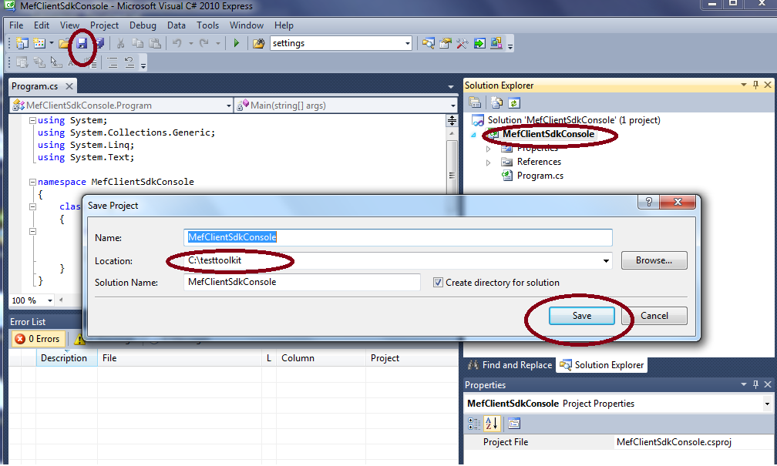

Step 3 - Now we are going to add some files from the release folder.
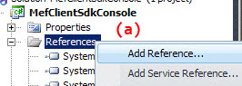
- Right click the “References” folder in your new project and select “Add References”.
- From the Add References dialog browse to the directory that contains the items extracted from the mef_client_sdk_.net.zip.
- Add the MeFWCFClient.dll to your project and select “OK”.
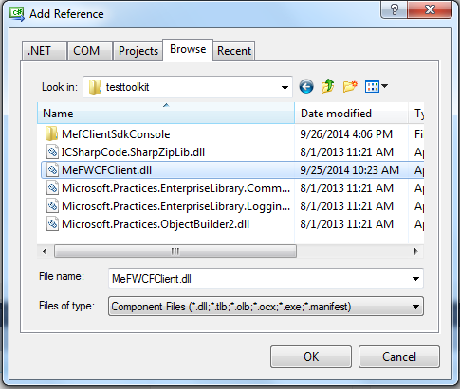

Step 4 – From the top menu select Project->MefClientConsoleProperties or just right click the project in solution explorer and select properties.
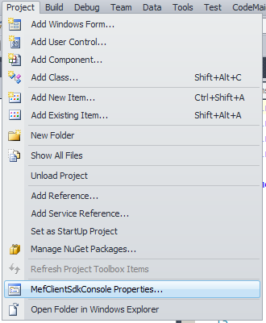

Step 5 – Make sure that the “Application” tab is selected and from the Manifest drop down box select the “Create application without a manifest” option. Change Framework to .NET 4. Press the save button & save the project.
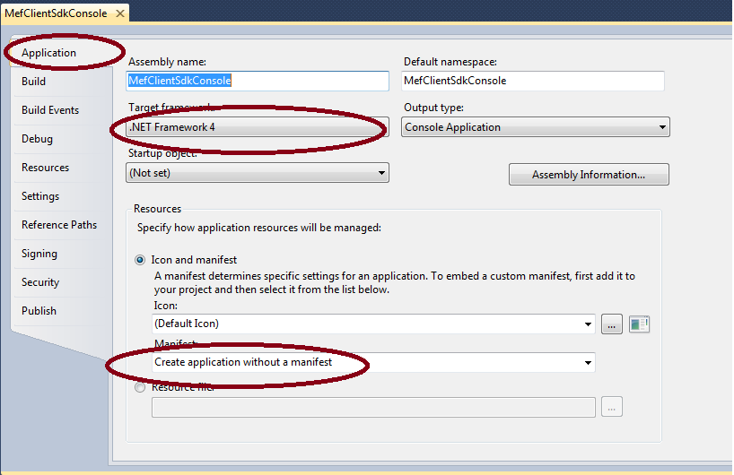

Step 6 – In the release folder locate the “mefclientsdk.config” file and drag it into your solution. Rename it to “app.config”.
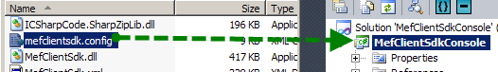
At this point you can start developing your own app to test the MefClientSdk, if you do not want to run the sample console skip over to Part II and learn how to setup the configuration file. If you want to run the sample console app continue to step 7.

Step 7 – Delete the “program.cs” file in the project and copy the over “program.cs” and “util.cs” from the SampleApp folder into the project.
Here’s what your solution should look like...
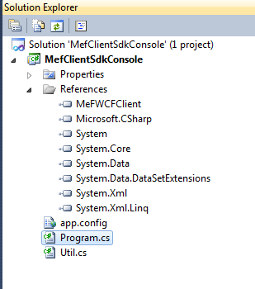

Step 8 – At this point build the solution and you should see something like the following depending on your visual studio setup.
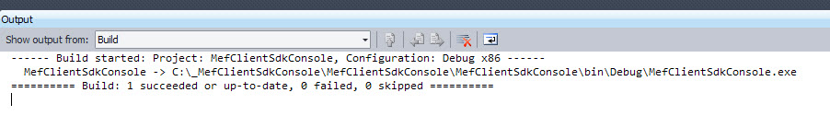
If you got build errors make sure that you have gone through the installation steps from the installation guide properly and that you have included all the references mentioned above in your project. If you still can’t build check the troubleshooting section for tips.

Part II – Working with the configuration values from the provided mefclientsdk.config.

This part of the guide covers the Client Settings section (shown on next page) within the configuration file. The focus here is how to set up your certificate and how these values relate to the certificate stores on your machine.

*Please note that the screenshots are from Windows XP, if you’re running Windows Server 2008 or Windows 7 the management consoles to work with certificates may look different.

Certificate Settings – The StoreLocation and StoreName properties
On the left is the built-in MMC console for managing certificates; on the right are the setting values from the mefclientsdk.config – specifically the settings for the store location and store name
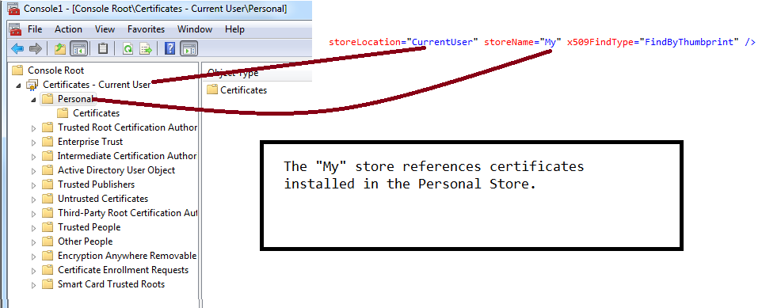

Certificate Settings – The X509FindType and FindValue properties
Here the actual certificate is shown on the left and the two relevant config. These are the values that were used for this sample – set your actual config values to one’s appropriate your specific certificate.
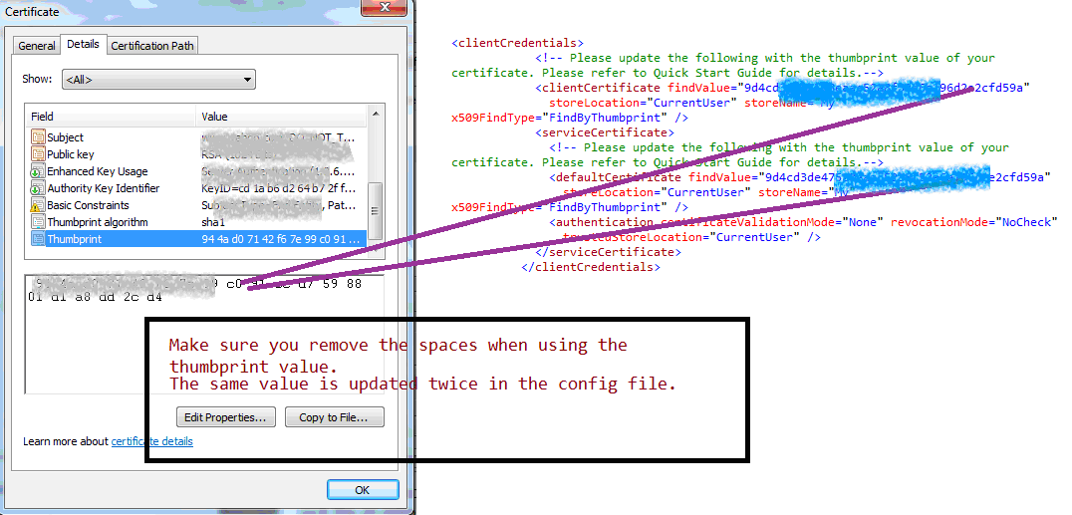

Certificate Settings – Identity dns value
Here the actual certificate is shown on the left and the relevant config. These are the values that were used for this sample – set your actual config values to one’s appropriate your specific certificate.
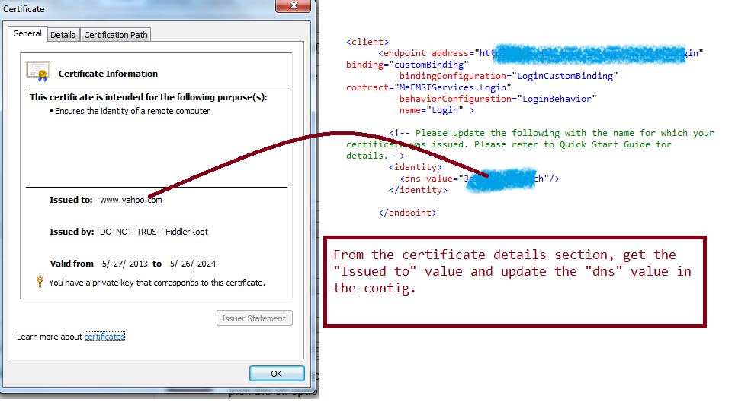

Certificate Settings – Quick glance at config sections other than certificate

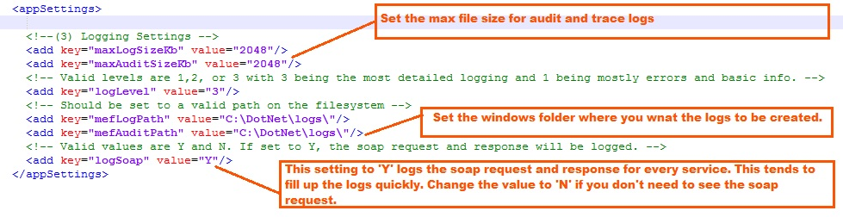

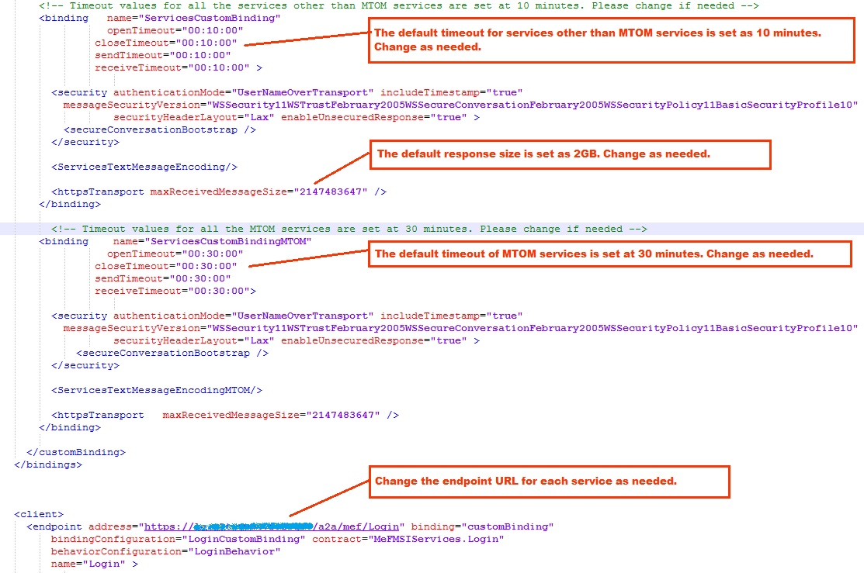

Part III – Walking through the samples in the console application.

Intro – This guides layout and examples.
This sample app is provided as is, the purpose of the app is to assist developers new to using the SDK.
With simplicity in mind each example demonstrates some high level function of a client API. Generally you will see a screenshot of the Console performing an action based on user input. Following that would be an image of the code that performs that action.
The console’s main menu (pictured below) …
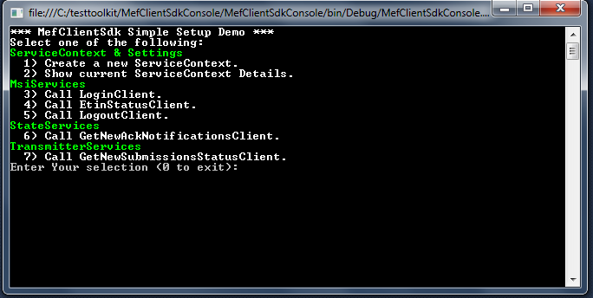

Creating a ServiceContext
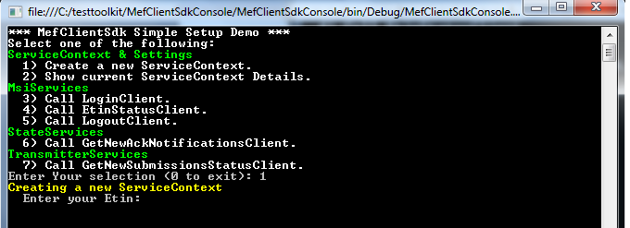

Enter 1 on the console menu and you will be asked to enter your etin and appsysid.
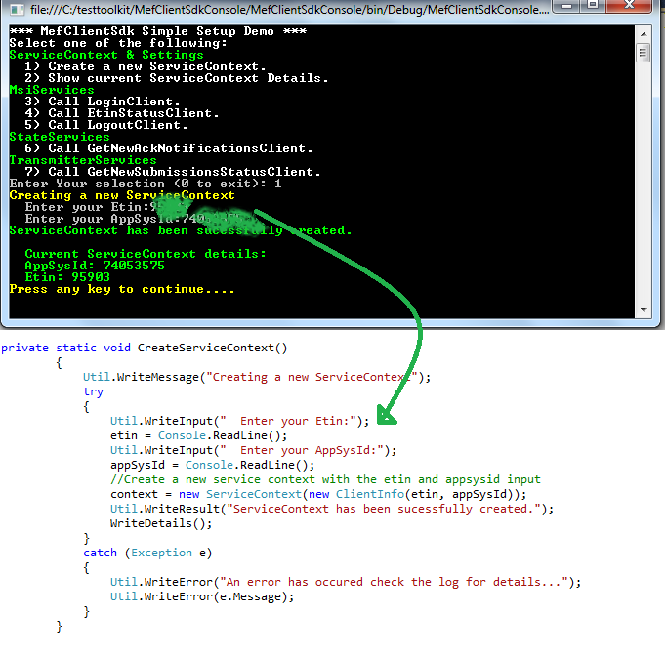
You will see the variable “context” used throughout the sample code, below you can see how its defined and how the details printed out on the console above get populated by call some methods on the context.

LoginClient
Enter option 3 and the console will attempt to login with the current ServiceContext.
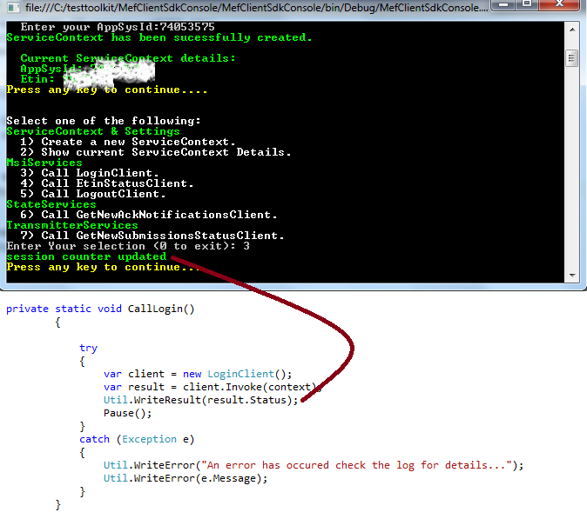

EtinStatusClient

Type in “4” and press enter to call EtinStatusClient. The next line will ask for the etin which is a required input parameter for invoking the service.
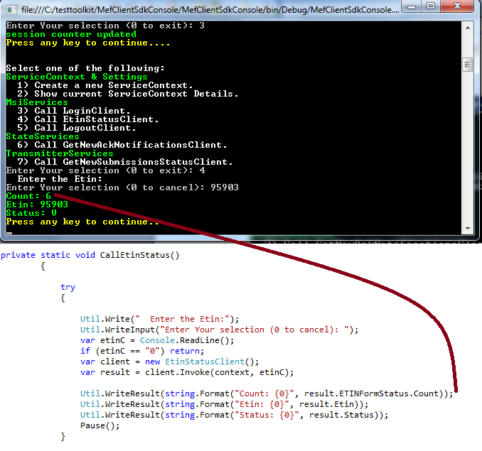

GetNewAckNotificationsClient

The following screen shows calling the service with option 6 and seeing the results in console.
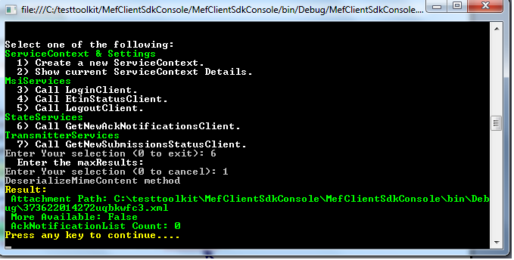

The code view for GetNewAckNotificationsClient.
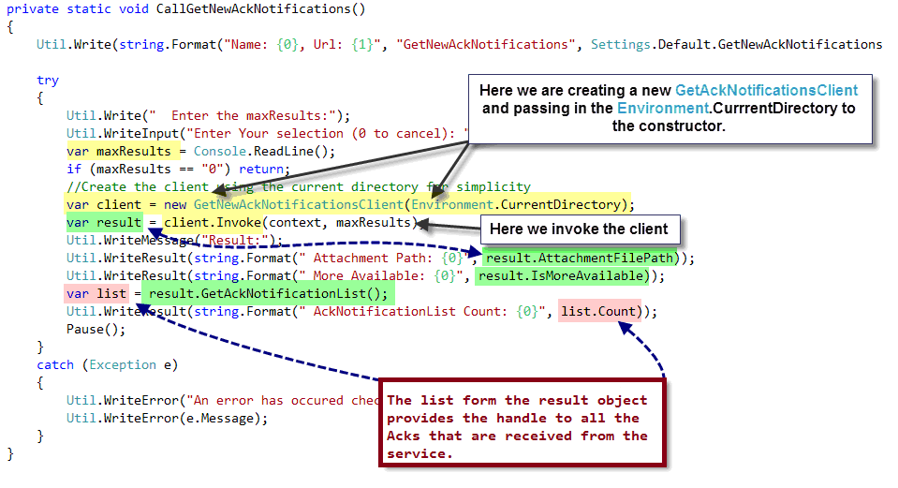
Here the console result is shown plus an image from files saved from that result to my file system.
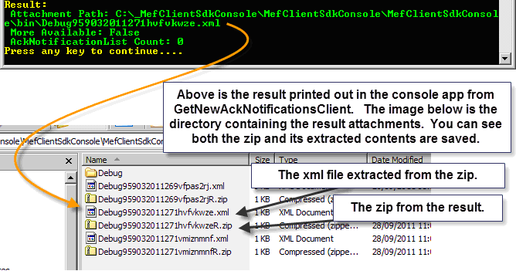

Below is a shot of the list opened in notepad

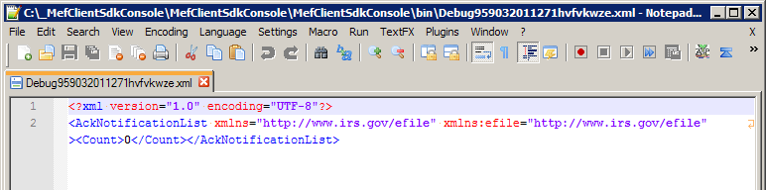
GetNewSubmissionsStatusClient

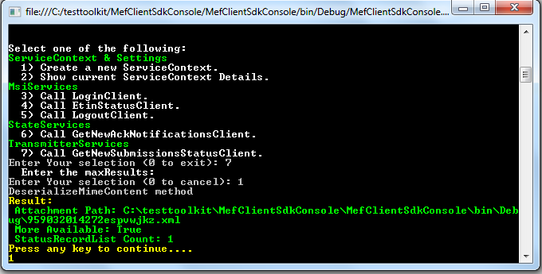

The code view is on the next page. The view includes an example of one of the efileattachments api’s (shown below) which is not included in the console app.
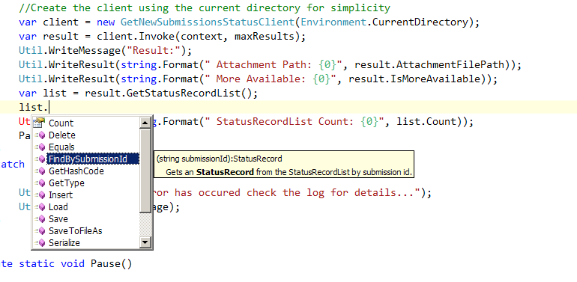Continue to see the complete code view on the next page.

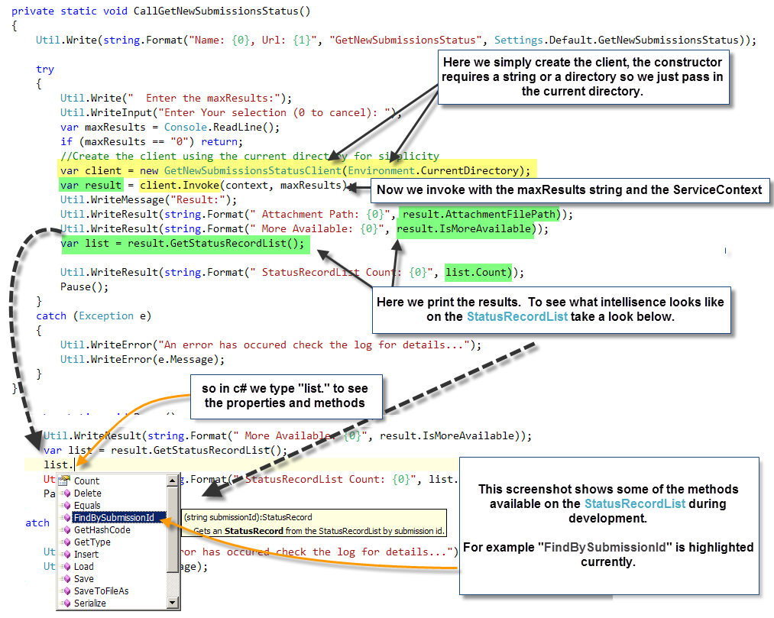

Part IV – Troubleshooting.

MeFWCFClient.dll references - Everything compiled, my application runs, but…
The most common error you may encounter during development is missing references exception. Usually this is because things are constantly moving and changing in some way during this stage. The exception for the “Could not load assembly ‘Microsoft.Practices…” may manifest itself in a variety of ways. Fortunately there are two simple ways to resolve this issue. First take a look at the scenario being reproduced on this machine. (Enterprise Library 4.1 is not installed on this machine).
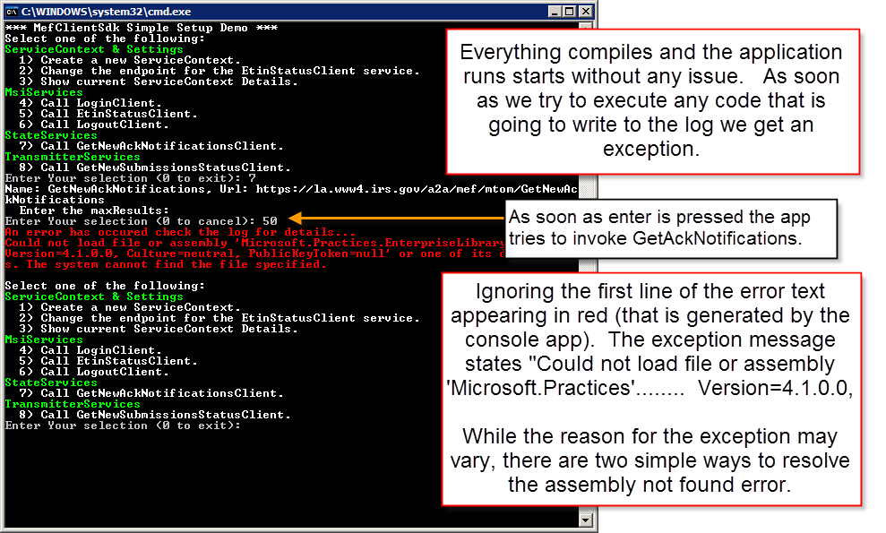

Continue to the next page…
Take a look at the development environment to see where the MefClientSdk.dll reference resides on the file system.
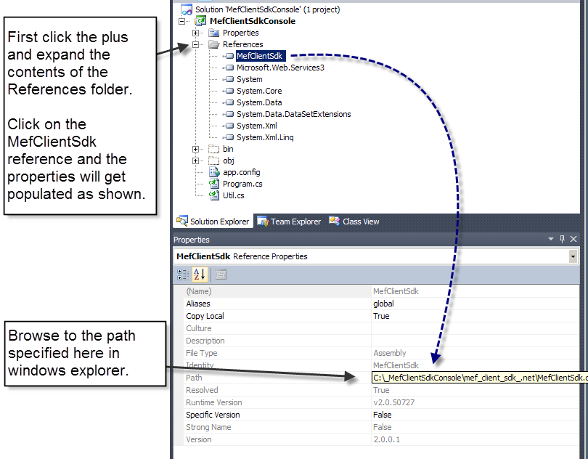

Continue to next page…
One solution is to always keep the release libraries in one place, that way you can avoid the “Assembly not found” exception.
Let’s say you already have the EnterpriseLibrary 4.1 installed or the .dll’s somewhere on your system and you want to use those for whatever reason. Simply add the references to the console app and rebuild.
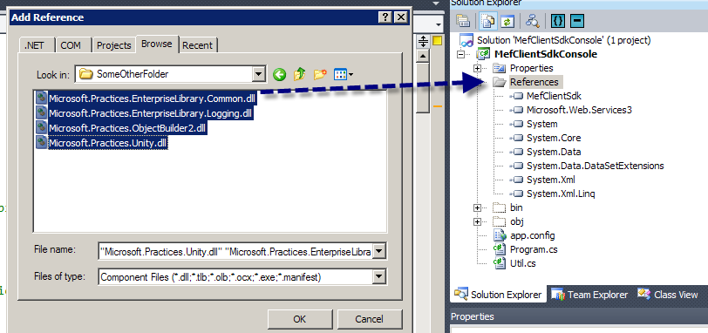

You are not restricted to using the files included with the release however you must be certain that you are using version 4.1 of the enterprise library. Using version 5.0 or earlier than 4.1 has not been tested and may cause undesirable results.

Hopefully this guide helps you get started developing your application with the toolkit, our plan is to add to it as the toolkit evolves. We welcome your input and suggestions on specific scenarios you think would help developers building on top of the SDK.

